Use Visual Studio 2013 Professional to open existing CBS project

auto project migration -> vs.net 2013

Modify each project target from .net framework 3.5 -> 4.8

Do the same for infra & common

re-reference from crystal report runtime for vs.net 2008 -> crystal report runtime for .net framework

Build.

Run Import Parcel Report (Monthly)

Test Result: PASS (The report looks the same as production)

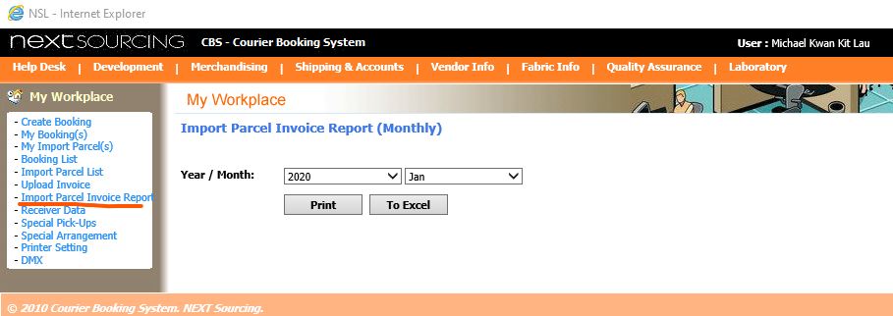

Upload Invoice

Test Result: PASS (Invoice was uploaded successfully)

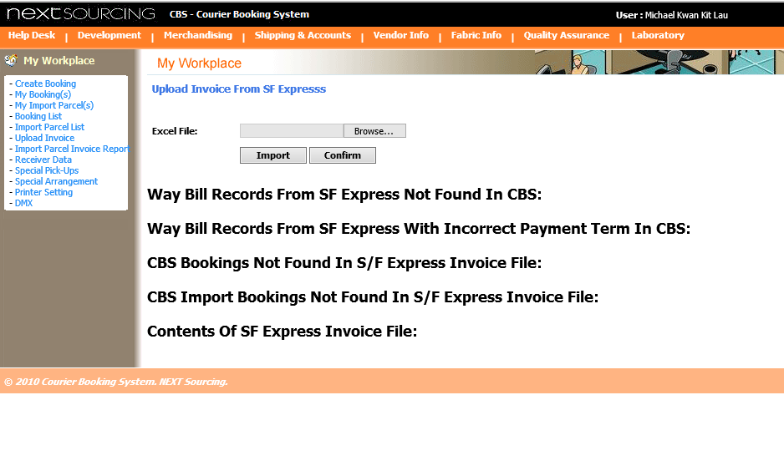

Create Booking

Test Result: PASS (Booking record was created successfully)

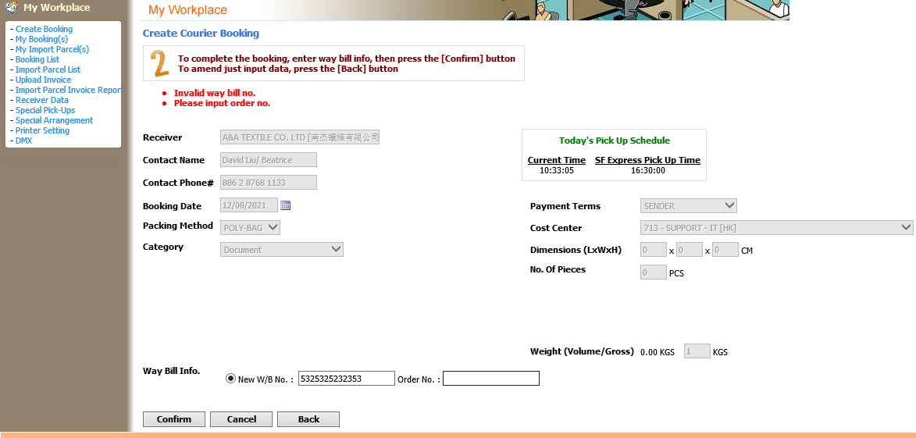

Search Booking

Test Result: PASS (Search result was displayed without any issue, layout the same as production)

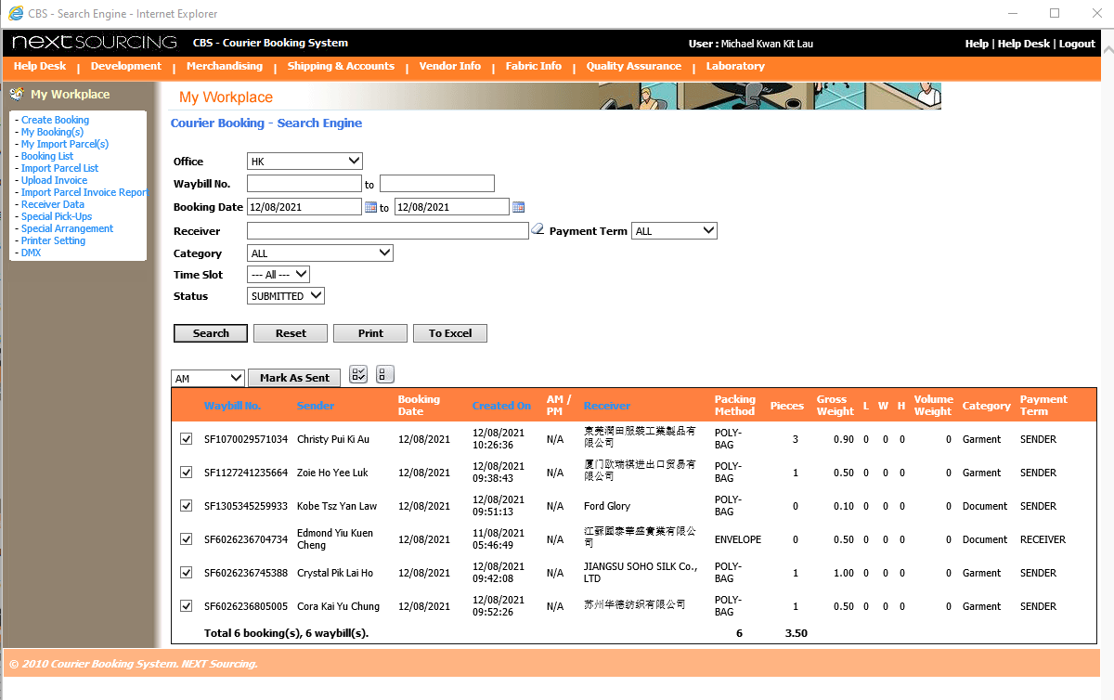

Deploy the project to IIS using 4.0 runtime.

Required: Testing on a clean .net 4.8 server machine.

# Smart Selection replacement

Source:

TFS\Isam\webapp\webservices\UclSmartSelectionAJAX.ascx

TFS\Isam\webapp\webservices\ SmartSelectionAJAXWebService.asmx

## How: to use

<%@ Register src="../webservices/UclSmartSelectionAJAX.ascx" tagname="UclSmartSelectionAJAX" tagprefix="uc2" %>

<uc2:UclSmartSelectionAJAX ID="txt_SupplierNameAJAX" runat="server" />

txt_SupplierNameAJAX.initControl(com.next.isam.webapp.webservices.UclSmartSelectionAJAX.SelectionList.ntVendor);

## get value:

int a = txt_SupplierNameAJAX.NTVendorId;

# Hiding param value in URLs (pop-up)

btn.Attributes.Add("onclick", "window.open('Example.aspx?paramA=" + HttpUtility.UrlEncode(EncryptionUtility.EncryptParam(id.ToString()))', 'changeCurrencyWindow', 'width=400,height=200,scrollbars=1,status=0');return false;");

# Decrypting param in pop-up page

int id = int.Parse(EncryptionUtility.DecryptParam(Request.Params["id"].ToString()));